http://journals.tums.ac.ir/upload_files/html/1119.jpg

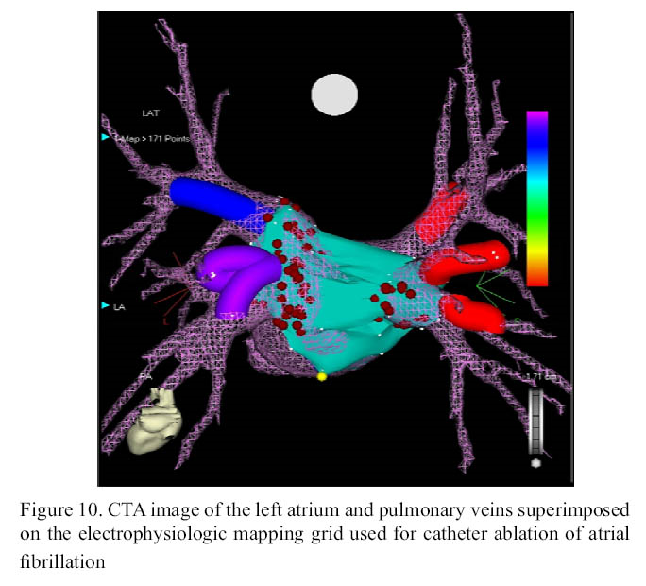
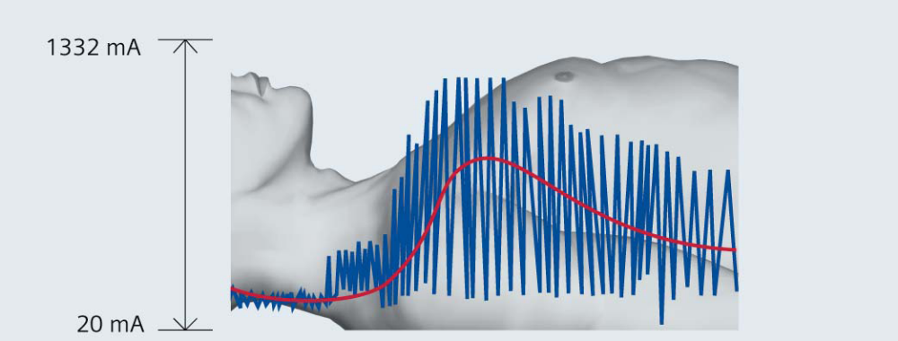

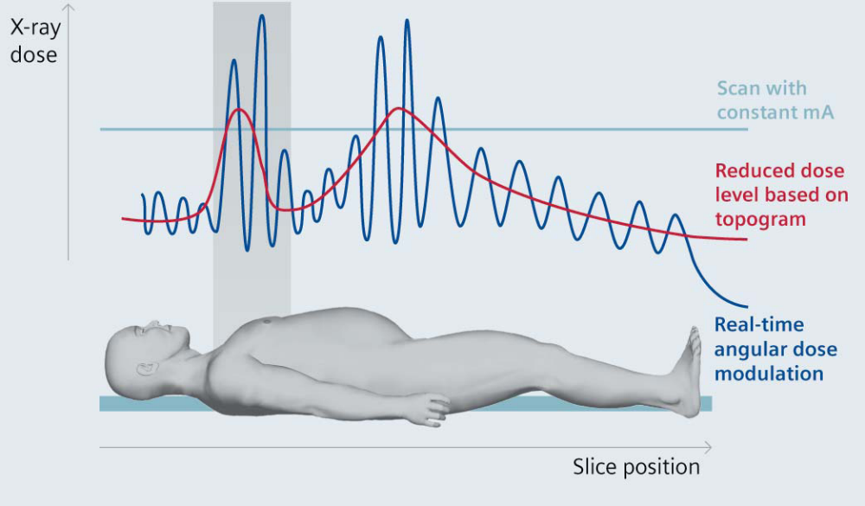

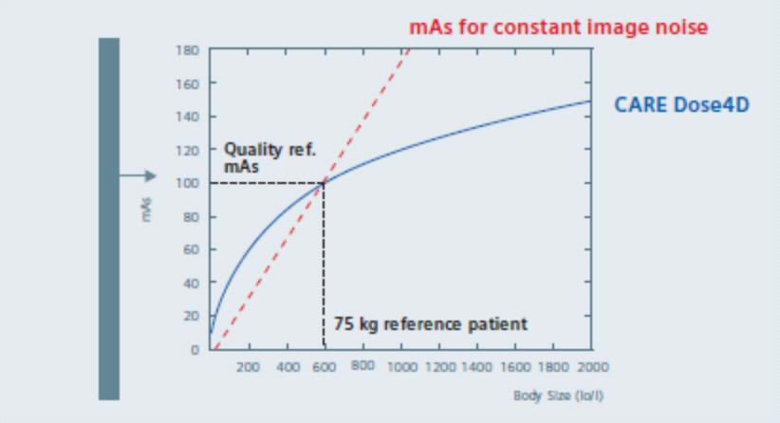
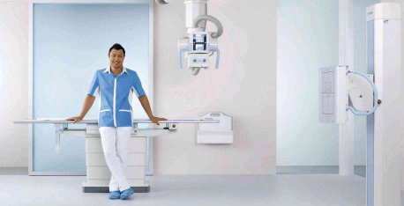

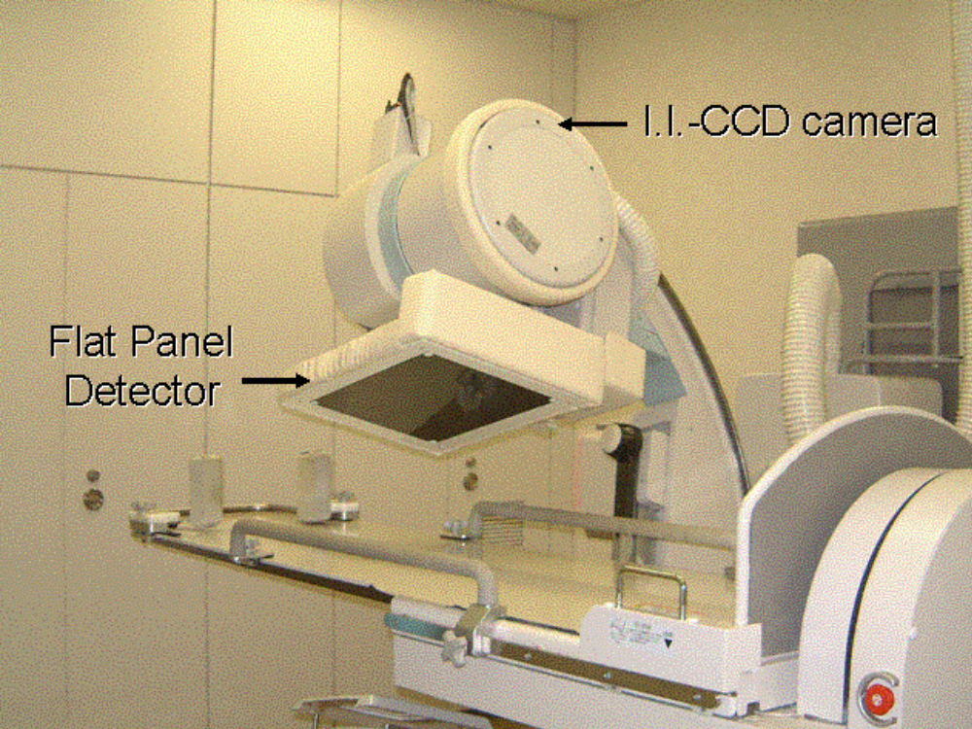
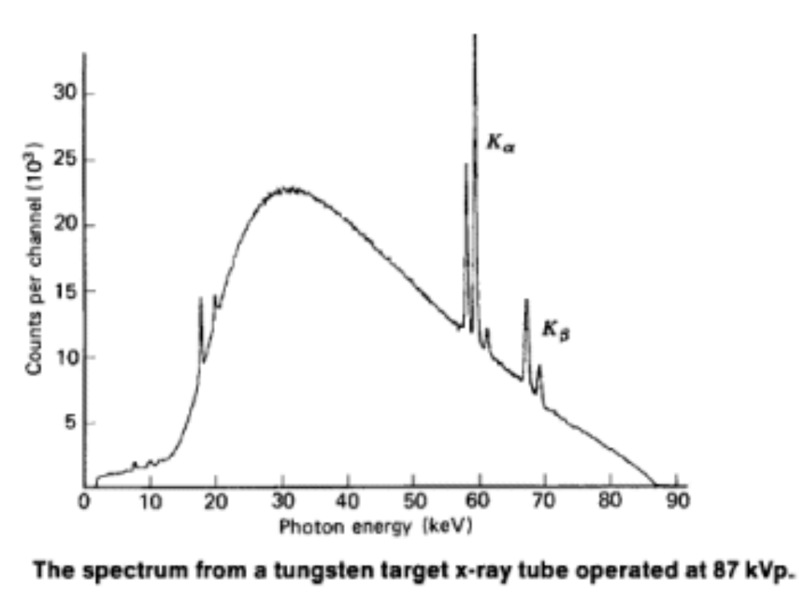
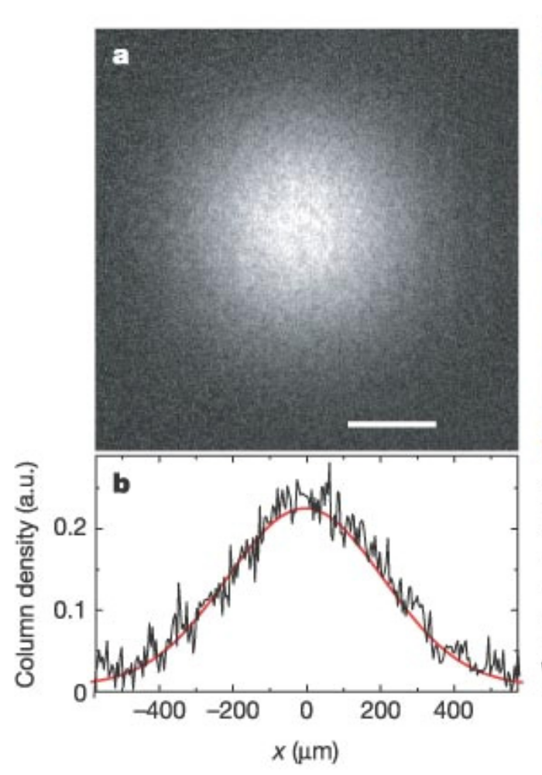

Orvosi képi megjel
http://www.radiologia.hu/radiwiki/index.php/K%C3%89PALKOT%C3%81S_ESZK%C3%96ZEI_-_avagy_az_orvosi_k%C3%A9palkot%C3%A1s_fizik%C3%A1ja

CYklotron
http://www.chem.elte.hu/Sandor.Nagy/NewClearGlossy/Cyclotron.htm

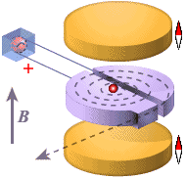

http://www.impactscan.org

Technical Specifications
Receptor Type:
Amorphous Silicon with Charge Well Pixel™ Technology
Conversion Screen:
Detached CsI, DRZ Plus, or Gd2O2S: Tb (Kodak Lanex Screen)
Pixel Area:
Total 42.7 (h) x 35.6 (v) cm (16.8 x 14.0 inch)
Active 42.4 (h) x 35.3 (v) cm (16.7 x 13.9 inch)
Pixel Matrix:
Total 3,072 (h) x 2,560 (v)
Active 3,052 (h) x 2,540 (v)
Pixel Pitch:
139 mm
Limiting Resolution:
3.6 lp/mm
Fill Factor:
100%
Scan Method:
Progressive
A/D Conversion:
14-bits
Image Preview:
1 sec.
Cycle Time (minimum / standard):
8 / 10 sec.
Data Output:
Gigabit Ethernet
Exposure Control
Inputs: Prepare, Expose-Request
Outputs: Expose-OK

